2025 TERM I MZIMBA NORTH DISTRICT EXAMINATIONS

CHEMISTRY FORM 2

(100 MARKS)

Wednesday 17 December 2025 Time allowed:2hours
7:30 – 9:30am

Instructions
- This paper contains 8 printed pages. Please check
- This paper contains section A, B and C

- Write your name and class at the top of each page of your question paper in the spaces provided.

- Answer all the 33 questions.

- Hand in your paper to the invigilator when time is called to stop writing.

SECTION A ( 20 MARKS)
MULTIPLE CHOICE
Encircle the letter with the correct answer

- Which branch of chemistry deals with techniques to find the quantity of each of the substances present in a mixture?
- Analytical chemistry
- Biochemistry
- Industrial chemistry
- Organic chemistry

- Accuracy is defined as
- the repetition of correct results
- how close the results are to correct answer
- how close the results are to each other
- the repetition of experiments

- Which of the following are isotopes of each other where p=number of protons and n=number of neutrons?

- 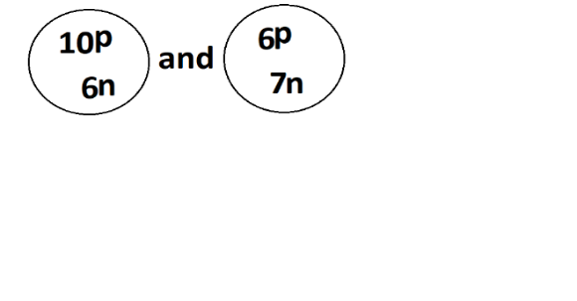
- 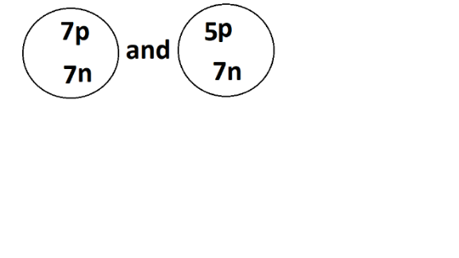
- 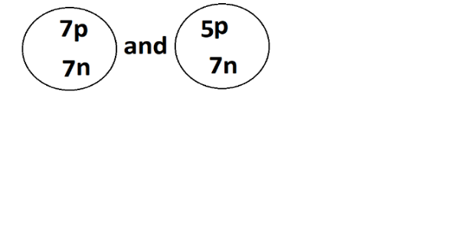
- 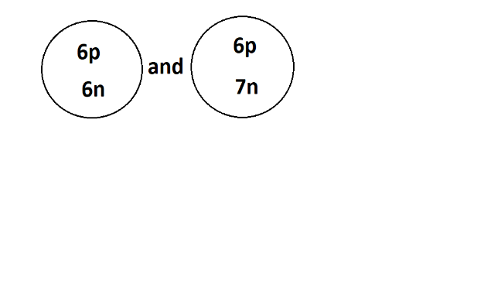

- Which of the following mixture is heterogeneous?
A. common salt and water
B. alcohol and water
C. salt and sand
D. sugar and water
- Hydrogen molecule is formed through combination of two hydrogen atoms by sharing electrons. Name the type of bond.
- Ionic bond
- Metallic bond
- Hydrogen bond
- Covalent bond

- Which of the following are stages in scientific investigation?
- identifying a problem
- formulation of a hypothesis
- identifying errors
- controlling errors
- 1 and 4
- 1 and 2
- 2 and 3
- 3 and 4

Table below shows the table of elements P and Q. Use it to answer questions 7and 8.

ELEMENT | MASS NUMBER | ATOMIC NUMBER | GROUP
P | 40 | 18 | 0
Q | 19 | 9 | 7

- What is the valency of element Q
- 7
- 1
- 2
- 9

- Which of the following is the chemical property of element P
- Are gases
- Does not react
- Non poisonous
- React with metals

- Write the value of 0.00507 in standard form
- 507 x 10²
- 5.07 x 10⁻³
- 50.7 x 10⁻⁴
- 0.507x10⁻²
- Which of the following reactions would result in the production of salt and water?
- Addition
- Combustion
- Neutralisation
- Substitution

- Which of the following substances is an element?
    - carbon dioxide
    - nitrogen gas
    - water
    - aluminum oxide

- The following affect solubility except
    - temperature
    - density
    - size of particles
    - pressure

- Which of the following metals is most reactive?
    - Potassium
    - Lithium
    - Sodium
    - Magnesium

- Which of the following are halogens?
    - Li and Na
    - P and N
    - F and Cl
    - He and Ne

- Electronegativity is the ability
    - to gain electrons
    - of an atom to attract the shared pair of electrons
    - of an atom to lose electrons
    - to form negative ions

- The formula of Ammonium nitrate is NH4NO₃. What is percentage composition of N in
NH4NO3
(RAM: N=14, H=1, 0=16).
    - 53%
    - 70%
    - 35%
    - 40%

- ​Which of the following is a chemical change?
    - burning of wood
    - grinding millet
    - melting candle wax
    - boiling of water

- Which of the following are properties of bases?
- they have a bitter taste
- they turn red litmus paper to blue
- they facilitate rusting
- they conduct electricity
  - 1.2 and 4
  - 1, 2 and 3
  - 2, 3 and 4
  - 1, 3 and 4
The figure below is a symbol for one of the common hazards. Use it to answer question 19.

- What is the meaning of the symbol?
- Flammable
- Irritant
- Corrosive
- Oxidising
- What is the trend of reactivity in halogens?
- Increases down the group
- Decreases down the group
- Is constant at room temperature
- Increase with increase in atomic radius

SECTION B (50 MARKS)
Answer all the questions in the spaces provided

- a. Differentiate a derived quantity from a basic quantity ________________________________________________________________________________________________________________________________________________________________________________________________________________________________________________ (2 marks)
- Why are most of the apparatus in chemistry laboratories made of glass? _____________________________________________________________________________________________________________________________________________________ (2 marks)
- a. State three uses of lithium metal _________________________________________________________________________________________________________________________________________________________________________________________________________________________________________________ (3 marks)
- Give three ways in which atoms attain stability. ___________________________________________________________________________________________________________________________________________________________________________________________________________________________________________________ (3 marks)
- An element is represented as ${}_{13}^{27}X$.

- Draw the structure of the atom X

(3marks)
- To which group of the periodic table does an atom X belong? ___________________________________________________________________
(1 mark)
- What is the number of neutrons of atom X 

(3marks)

- The figure below shows a chemical bonding between sodium and oxygen
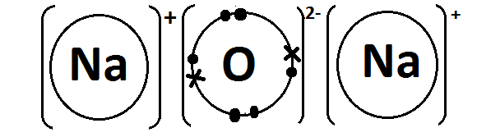
- Name the type of bonding shown above ________________________________________________________________ (1 mark)
- Give a reason to your answer. ______________________________________________________________________________________________________________________________________________________________ (2 marks)
- a. State two ways of determining the strength of an acid. ______________________________________________________________________________________________________________________________________________________________ (2 marks)
- List two advantages of local indicators in identifying acid and base ______________________________________________________________________________________________________________________________________________________________ (2 marks)
- a. State methods of separating the following
  - ink _________________________________________________________________
  - salt solution _________________________________________________________
  - petroleum ___________________________________________________ (3 marks)

- Mention two ways of making saturated solution unsaturated _________________________________________________________________________________________________________________________________________________________ (2 marks)

- The equation shows the reaction between sodium metal and water

Na_{(s)} + H₂O_{(l)}  NaOH_{(aq)}+ H_{2(g)}
- What does (l) and (aq) mean in an equation above?
(l) ______________________________________________________________
(aq) _____________________________________________________ (2 marks)
- Balance the equation _______________________________________________________________________________________________________________________________________________________________________________________________________________________________________ (2 marks)

- If 60g of Na was used what would be the mass of NaOH produced. (RAM: Na = 23. O =16, H = 1)
 (4 marks)
- a. (i) Define fractional distillation.
_______________________________________________________________________________________________________________________________________________________ (1 mark)

(ii). Why is carbon dioxide and water removed first during fractional distillation of liquid air.
_________________________________________________________________________________________________________________________________________________________ (2marks)

- Explain why element Cl is more electronegative than Element P
____________________________________________________________________________________________________________________________________________________________________________________________________________________________________________ (3 marks)
- (a) Element oxygen contains 90% of ${}_{8}^{16}O$, and 10% of ${}_{8}^{ 18}O$. Calculate the Relative Atomic Mass of Oxygen.


(3 marks)

(b) table below; Shows different types of substances.
Substance | type
Cocacola
Water
Nitrogen

- Complete the table by filling type of substance as element, compound and mixture. (3marks)

- Give any one difference between a mixture and a compound.
__________________________________________________________________________________________________________________________________________________________________________________________________________________________________________________ (1 marks

SECTION C (30 MARKS)
- a. Explain any two applications of neutralization reaction. __________________________________________________________________________________________________________________________________________________________________________________________________________________________________________________________________________________________________________________________________ (4 marks)
b. Explain clearly how you can produce an acid -base indicator using Hibiscus fruits.
____________________________________________________________________________________________________________________________________________________________________________________________________________________________________________________________________________________________________________________________________________________________________________________________________________________________________________________________________________________________________________________________________________________________________________________________ (6 marks)

  - Explain how the reactivity of group VII elements differs from that of group I elements of the periodic table.
_____________________________________________________________________________________________________________________________________________________________________________________________________________________________________________________________________________________________________________________________________________________________________________________________________________________________________________________________________________________________________________ (4 marks)

- Using well balanced chemical equations, explain any two chemical properties of alkaline-earth metals ______________________________________________________________________________________________________________________________________________________________________________________________________________________________________________________________________________________________________________________________________________________________________________________________________________________________________________________________________________________________________________________________________________________________________________ (6 marks)
- With the aid of a well labeled diagram, describe how you can obtain pure water from the mixture of water and ethanol.

_____________________________________________________________________________________________________________________________________________________________________________________________________________________________________________________________________________________________________________________________________________________________________________________________________________________________________________________________________________________________________________________________________________________________________________________________________________________________________________________________________________________________________________________________________________________________________________________________________________________________________________________________________________________________________________________________________________________________________________________________________ (10 marks)
END OF QUESTION PAPER

